

Reception Newsletter Autumn 1

It has been a pleasure spending time with your children over the past few days and beginning to build positive relationships with them. We’ve been so impressed by how quickly they have settled in and how confident they have been. What a brilliant start to the school year! We’re confident that we’re going to have a fantastic year together. To support the children in settling into their new classroom and forming connections across the school, we’ve planned a range of activities focused on relationship-building and exploration. If you have any questions or concerns about your child please do not hesitate to come and arrange a time to speak to us either at the door when you are dropping off or via our school email school.office@stanningleyprimary.com
Ms Read and Mrs Holgate

Our learning
During the first few weeks, staff will spend lots of time engaging with the children during self-chosen activities, helping to foster strong relationships and a sense of belonging. We’ll also be establishing Reception class routines, including tidying up and caring for our Early Years environment, which will support the children in becoming more independent. We’ll be encouraging them to put on their own coats and footwear, and to manage their personal hygiene, all of which are important steps in developing their independence.

Exploring Family and Belonging
As part of helping the children feel a strong sense of belonging, we’ll be spending lots of time getting to know one another, talking about our families, and learning about where we live. To support this, we kindly ask that you send in a photo of your child with their family. Photos can be emailed to the above address. These will be printed out and displayed in the classroom to help the children feel proud and connected. We’ll be exploring a range of books to support these discussions, including:
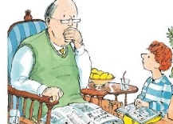
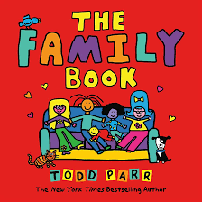
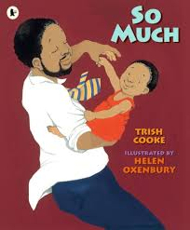
The Family Book by Todd Parr – a bright and inclusive story that celebrates all kinds of families. So Much by Trish Cooke – a joyful tale about a family gathering to celebrate Dad’s birthday and Storm by Sam Usher – a gentle story about a boy and his grandad sharing memories as they search for a kite to fly in the autumn wind.

Belonging to Other Groups
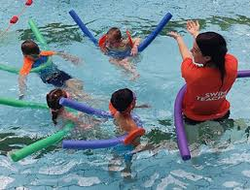
As well as our families, we will also be talking about other groups that the children might belong to. These include our school, class, community, swimming class, football class, gym class, or places of worship. If your child belongs to any groups outside of school, we would love to hear about them. It would be lovely if your child could send photos to share or certificates to show to their friends.


Observing Seasonal changes
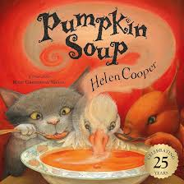
We will be observing the seasonal changes around us as the Summer slowly turns into Autumn. Particularly thinking about the leaves on the trees and discussing how they are changing as well as harvesting some of the apples and pears from the trees around school. Towards the end of the half term, we will be looking at the story Pumpkin Soup. It is a great story for us to introduce the idea of sharing and taking turns as well as fitting in with the theme of autumn. We will also be cutting up our pumpkins to make into soup.
Phonics
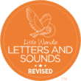
During the first full week, the children will play simple phonics games to help them settle in and become familiar with the classroom routines. We will then begin our school phonics scheme, Little Wandle, where the children will be taught a new phoneme (letter sound) each day. They will also start learning to blend these sounds.
Just to remind you our Phonics Meeting will be held on Tuesday 8th September at 5:30 pm. This session will explain the phonics programme in more detail and provide guidance on how you can support your child’s learning at home. It is really important that you support your child with their learning at home to help them secure their learning in school.

Maths
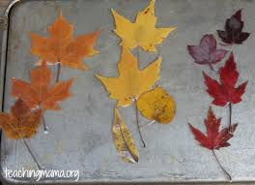
In Maths, the children will enjoy singing number songs such as Five Little Speckled Frogs and will explore mathematical concepts through purposeful activities woven into our daily routines. We will be introducing them to key early maths skills including matching, comparing, sorting, and creating repeating patterns. These foundational skills help build a strong understanding of number, shape, and logic in a fun and engaging way.

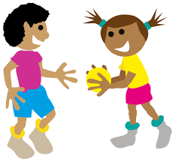
P.E. – The children will take part in 2 PE sessions a week which will take place on Wednesday and Friday. Please ensure your child is dressed in their P.E. kit on these days -plain black shorts/joggers (no logos), white round necked t-shirt and trainers please. It is school policy NOT to wear jewellery. However small studs may be worn in ears but MUST be removed for P.E days and long hair must be tied up.
Baseline Assessment
Schools are required to carry out a baseline assessment as set out by the Government within the first 6 weeks of pupils starting reception. No numerical score is shared and the data will only be used at the end of year 6 to assess how much progress the children have made throughout their time in school . However, school will receive a series of short, narrative statements that tell us how the children have performed in the assessment. These can be used to inform teaching within the first term. These assessments will be carried out by myself. If you have any queries please speak to a member of staff.


- Tuesday 8th September 5.30 pm - Phonics Meeting
- Tuesday 22nd September- Flu Vaccinations
- Thursday 1st October – School Photos
- Friday 23rd October -School closes for half term.

